**Assignment 2**

Name: Priya Chougale

Roll No : 323012

PRN : 22011171

Title :

**Theory:**

**1) What is Shell (Linux kernel architecture diagram)**

Shell is the interface between user and kernel. It is a command-line interpreter and is the interface between the user and the kernel. The user can enter commands to the shell. Then it interprets the commands to perform the required task. Furthermore, it executes programs and shell scripts. A shell script is a set of commands. The user should follow the standard syntax to write commands to the shell.

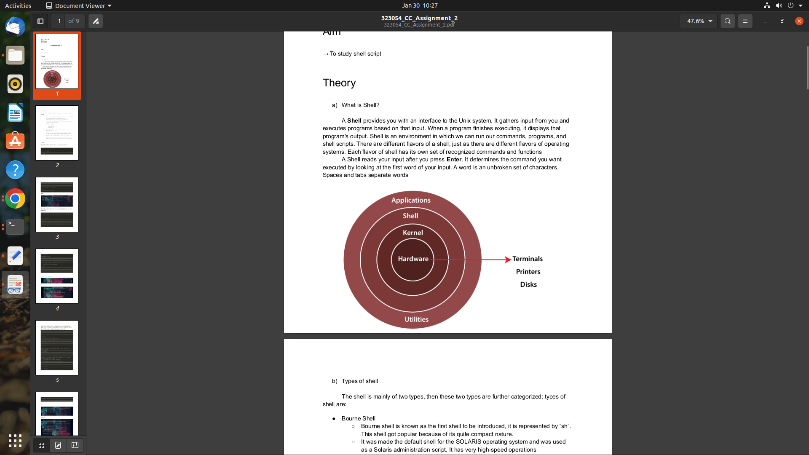

**2) Different types of shells**

**​1.** **The Bourne Shell**

The Bourne shell (sh), written by Steve Bourne at AT&T Bell Labs, is the original UNIX shell. It is the preferred shell for shell programming because of its compactness and speed. A Bourne shell drawback is that it lacks features for interactive use, such as the ability to recall previous commands (history). The Bourne shell also lacks built-in arithmetic and logical expression handling.

The Bourne shell is the Solaris OS default shell. It is the standard shell for Solaris system administration scripts. For the Bourne shell the:

* Command full-path name is **/bin/sh** and **/sbin/sh**.
* Non-root user default prompt is **$**.
* Root user default prompt is **#**.

**​2.** **The C Shell**

The C shell (csh):

* Is a UNIX enhancement written by **Bill Joy** at the University of California at Berkeley.
* Incorporated features for interactive use, such as **aliases** and **command history**.
* Includes convenient programming features, such as **built-in arithmetic** and a **C-like expression syntax**.

For the C shell the:

* Command full-path name is **/bin/csh**.
* Non-root user default prompt is hostname **%**.
* Root user default prompt is hostname **#**.

**​3.** **The Korn Shell**

The Korn shell (ksh):

* Was written by **David Korn** at AT&T Bell Labs
* Is a superset of the Bourne shell.
* Supports everything in the Bourne shell.
* Has interactive features comparable to those in the C shell.
* Includes convenient programming features like **built-in arithmetic** and **C-like arrays**,**functions**, and **string-manipulation facilities**.
* Is faster than the C shell.
* Runs scripts written for the Bourne shell.

For the Korn shell the:

* Command full-path name is **/bin/ksh**.
* Non-root user default prompt is **$**.
* Root user default prompt is **#**.

​4. The GNU Bourne-Again Shell

The GNU Bourne-Again shell (bash):

* Is compatible to the Bourne shell.
* Incorporates useful features from the Korn and C shells.
* Has arrow keys that are automatically mapped for command recall and editing.

For the GNU Bourne-Again shell the:

* Command full-path name is **/bin/bash**.
* Default prompt for a non-root user is **bash-x.xx$**. (Where x.xx indicates the shell version number. For example, bash-3.50$)
* Root user default prompt is **bash-x.xx#**. (Where x.xx indicates the shell version number. For example, bash-3.50$#)

Comparison of the all 4 shells and their properties.

| **Shell** | **Path** | **Default Prompt (non-root user)** | **Default Prompt (Root user)** |
| --- | --- | --- | --- |
| The Bourne Shell (sh) | /bin/sh and /sbin/sh | $ | # |
| The C Shell (csh) | /bin/csh | % | # |
| The Korn Shell (ksh) | /bin/ksh | $ | # |
| The GNU Bourne-Again Shell (Bash) | /bin/bash | bash-x.xx$ | bash-x.xx# |

Problem statements for shell scripting:

**2a) Write a shell script to check user is root user or not**

[HINT: study "id" command in linux]

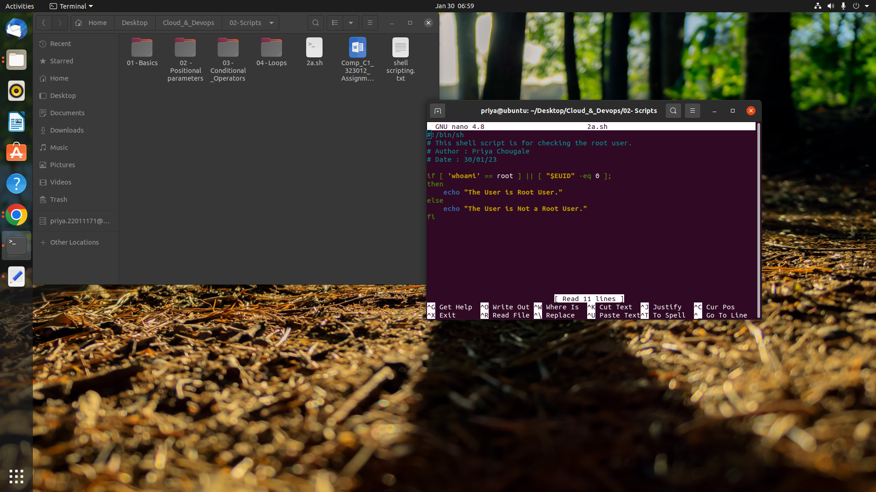

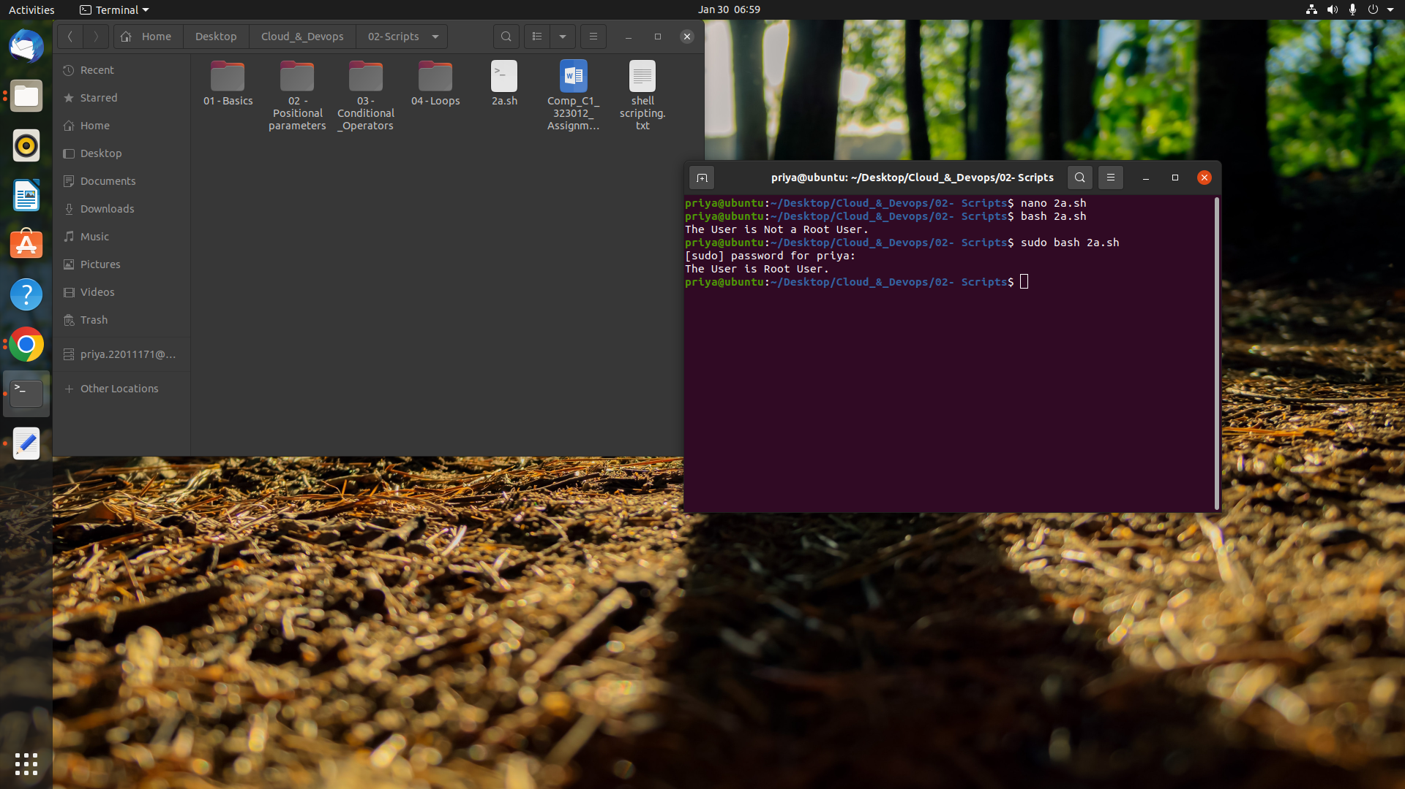

**2b) Write a shell script to install any particular software (ex: java or python)**

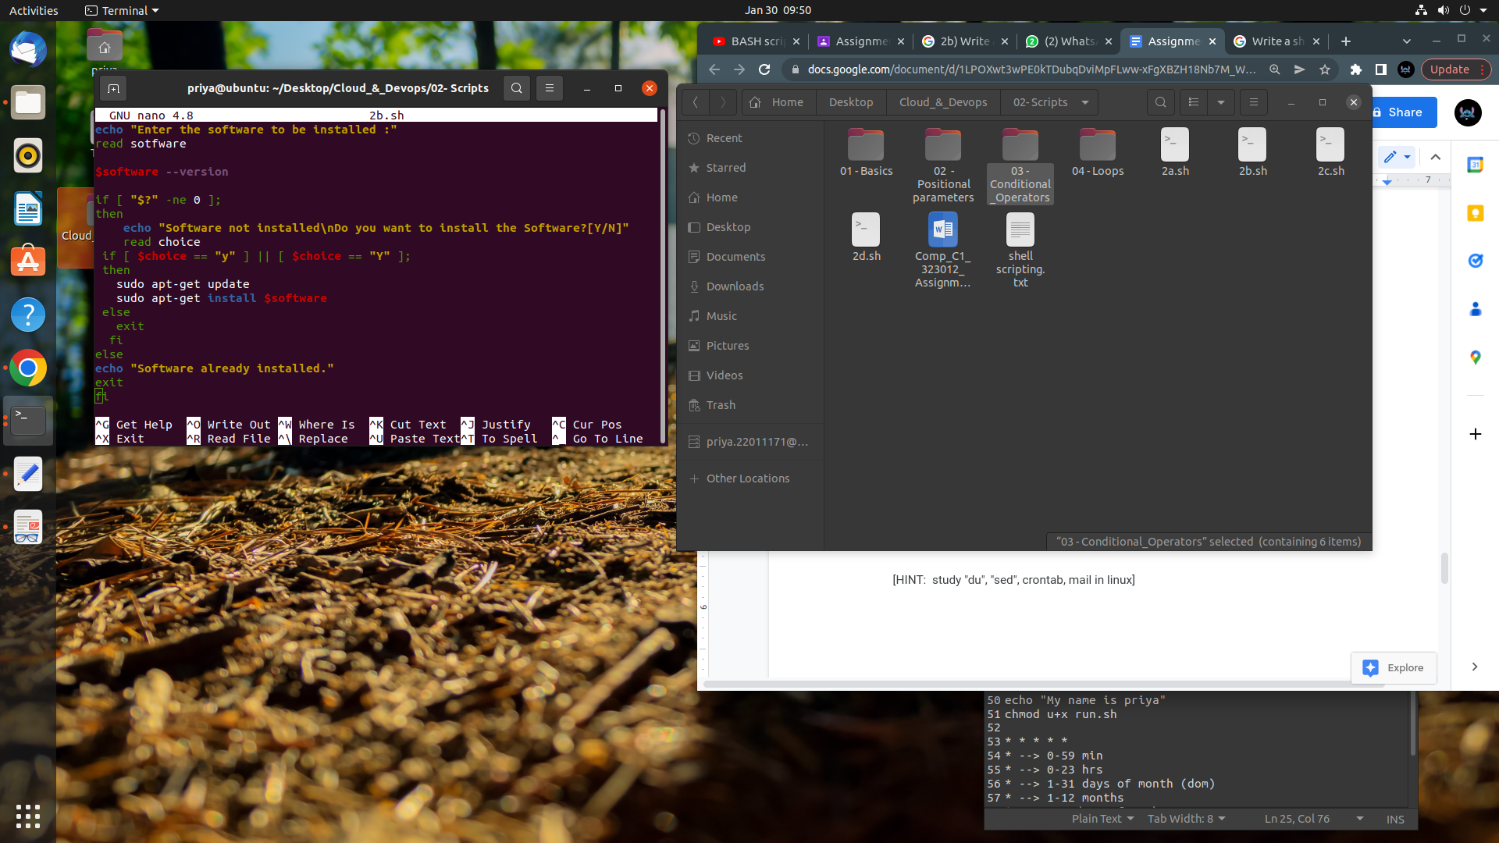

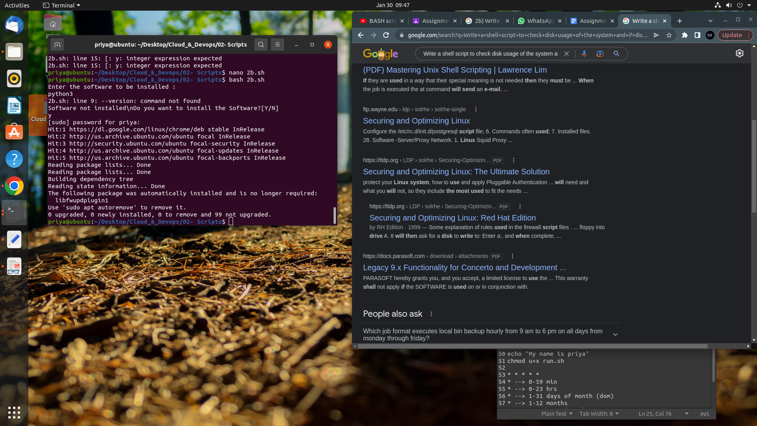

**2c)**

**Write a shell script to check disk usage of the system and if disk**

**usage is more than 90% it should send an email to system admin. This**

**script should run everyday at 8:00 AM.**

[HINT: study "du", "sed", crontab, mail in linux]

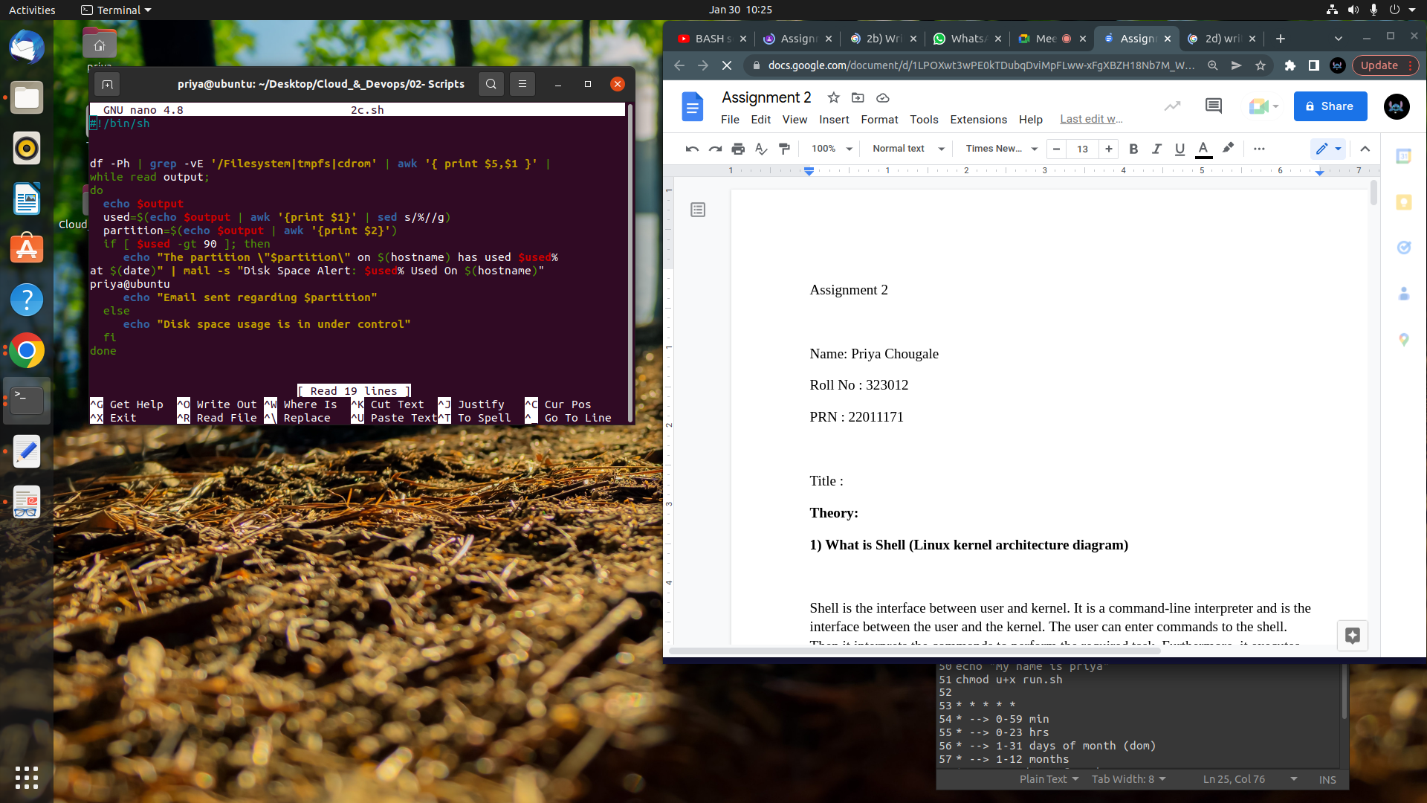

**2d) write a shell script to take mysql database server backup. This script should run weekly on every sunday at 11:00 PM.**

[HINT: study "mysql" dump, crontab in linux]

